Investigation of DEVELOPMENT of the harmonic composition
of EMF during THE PROCESS OF CUTTING

Smirnova M., Ivchenko T., Mezhenkov A. (DonNTU, t. Donetsk, Ukrain)

On étudie les régularités du changement de la composition harmonieuse de la force électromotrice en fonction de l'usure de l'outil coupant en train de la coupe. Pour une estimation comparative la composition harmonieuse de la force électromotrice à l’usinage par la coupe dans de diverses conditions d’usinage on propose le coefficient relative nonsinusoїde.

The improvement of operation methods based on mathematical modeling of their functioning is perspective directions for increasing efficiency of modern machining systems. At the present time mathematical modeling of processes and systems mechanics is quite common [1]. In this connection there is nesessity to improve both experimental and theoretical methods for studying them.
The use of modern systems of machining a measuring systems with analog-digital converters expands significantly the possibilities of research parameters of the cutting process. Mathematical apparatus for signal analysis is very extensive and widely used in practice.
In paper [2] problems of the effect of cutting electromotive force (EMF) on the machined surface roughness are solved on the basis of correlation and spectral analysis.
In paper [3, 4] a method for determining the harmonic content of signals (voltages and currents) that arise when measuring the forces and cutting temperature in steady state and transient conditions is proposed. As a result of the research the possibility to extend the scope of the well-known in electrical systems methods for determining harmonic content of phase currents and voltages is proved [5].
However, in the presented method of signal processing arising during the measurement of electromotive force, force and cutting temperature, insufficient attention is paid to the possibility of comparative analysis of their harmonic chemical composition depending on the conditions of machining. It is of interest the further development of this technique for various conditions of the cutting system operation.
The aim of the paper is to study the patterns of change in harmonic composition of the EMF, depending on the depreciation of the cutting tool in the course of the cutting process.
The main parameter of the cutting process investigated in this work – EMF represented in the form of the oscillograms obtained during operation of the CNC turning lathes of the type 16K20Ф3 using the strain gauge amplifier TA-5, strain gauges and an analog-digital converter of the model ADC-16 (PicoLog Ltd. Company).
Experimental conditions: processing of material - steel 45; tool material T5K10; turning diameter d = 45mm; processing modes: the depth of cut t = 1mm, feed S = 0.4mm/ob, cutting speed V = 80m/min, the rotational speed n = 200 s ⁻¹. Measurement of depriciation was carried out with a magnifying glass to press Brinell.
As a result of analysis of regularities of the change of depriciation on the rear surface of the cutting tools blade for the given conditions a linear behavior of the depriciation change in time in the investigated range of parameters: h_{теор} = 0,05 0,015t.
For each of the registered values of depriciations waveforms Е_{экпс} were measured. They are shown in Fig. 1.
The initial emf is represented as Fourier series:
$i(t)=\text{Ao}+\sum_{k=1}^{∞}{I_{\text{mk}}\text{cos}(kωt−ϕ_{k})}=\text{Ao}+\sum_{k=1}^{∞}{B_{k}\text{sin}kωt+}\sum_{k=1}^{∞}{C_{k}\text{cos}kωt}$, (1)
where Ао - constant component, $B_{k}$ and $C_{k}$ - ratios defined as the average values of n variables selected discretly within an interval:

$\text{Ao}=\frac{1}{T}\int_{{−T}/2}^{T/2}{i(t)\text{dt}≈\frac{1}{n}\sum_{s=1}^{n}{i_{s}}}(t)$; $B_{k}=\frac{2}{T}\int_{{−T}/2}^{T/2}{i(t)\text{sin}(kωt)\text{dt}}$$\frac{2}{n}i(s\frac{T}{n})\text{sin}(\text{ks}\frac{T}{n})$;
$C_{k}=\frac{2}{T}\int_{{−T}/2}^{T/2}{i(t)\text{cos}(kωt)\text{dt}}$$\frac{2}{n}i(s\frac{T}{n})\text{cos}(\text{ks}\frac{T}{n})$.
where $I_{\text{mk}},ϕ_{k}$ - peak value and the initial phase of the k-th harmonic EMF; $I_{\text{mk}}=\sqrt{B_{k^{2}}+C_{k^{2}}}$; $ϕ_{k}=\text{arctg}({B_{k}}/{C_{k}})$.
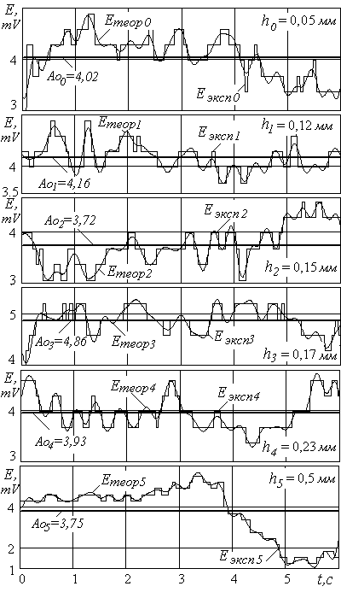
Harmonic composition of the initial oscillations obtained as a result of decomposition in Fourier series - Е_{теор} also presented in Fig. 1.
Fig. 1. Initial oscillograms EMF - Е_{эксп}
and their harmonic composition on results
decomposition in the row of Fourier – Е_{теор}
for the variants of treatment with the different wears of instrument

In accordance with the given methodology the program allowing to decompose the original curve of EMF in a Fourier series with different number of harmonics is developed. The adequacy of the proposed method is evaluated by the degree of coincidence of the original waveform with the resultant curve obtained by the sum of harmonic components.
Comparison of the initial EMF waveforms Eekspi obtained by measurement with theoretically calculated Eteori represented in Fig. 2, shows rather good their coincidence (error less than 10%).
It confirms the adequacy of the calculations and experiment, and the possibility of using the proposed method of calculation in practice.
Coefficient of anharmonicity К_{Н} [5]:

$K_{H}=\text{100}I_{k}/I_{\text{HOM}}$, (2)

where I_{HOM} - effective value of EMF; I_{k} - EMF of k-th harmonic.
The results of the calculation of the anharmonicity coefficient К_{Н} both according to the permanent components and according to the structure of the harmonic series and the degree of influence on the resulting signal does not allow to confirm their similarities or differences.
For a comparative analysis of the structure of the harmonic series in the present paper, we propose to introduce a relative ratio nonsinusoidality К_{Н}. which is the ratio of the estimated coefficient of anharmonicity К_{Н} to the coefficient taken as a basis for comparison К_{Нбаз}:
$K_{o}=K_{H}/K_{\text{Нбаз}}$, (3)

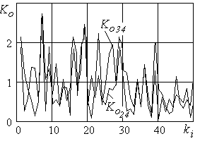
Fig. 2 shows the relative coefficients of anharmonicity for the variants of mechanical treatment with a slightly different tool depriciations. The coefficients of anharmonicity characterizing the machining with depriciations on the back surface of the shear h1 = 0,12 mm and h2 = 0,15 mm are compared with processing tool by shear when h3 = 0,17 mm:
Fig. 2. Graphs of relative coefficients of
anharmonicity

$K_{o\text{24}}=K_{H2}/K_{Н4}$;
$K_{o\text{34}}=K_{H3}/K_{Н4}$.

For this variant the values of relative anharmonicity coefficients K_{o24} and K_{o34} differ very little and their average values are close to 1. It testifies that there are no significant differences in the structure of the harmonic series of compared variants.
The curve of relative anharmonicity coefficients for the variants of treatment withing the range of the tool depreciation change are shown in Fig. 3. As a basis for comparison the variant of tool treatment with practically undepreciated shear - h₀ = 0,05 mm:

$K_{\text{oi}}=K_{\text{Hi}}/K_{Н0}$.

Curves of relative anharmonicity coefficients К_{о1} confirms the fact that in case of tool depreciation the groop of harmonic which exeed the other harmonics and the tool depreciation is more the range of harmonics becomes more narrow.
It is defined that for the highest experimental values of depreciations (h₅ = 0,5 mm) the value of the relative anharmonicity ratio K_{o5} is significantly higher than the rest ones for the 13-harmonic, that is the degree of influence of the harmonic on the resulting signal is very significant and reflects the characteristic changes associated with features of compared variants. In accordance with the proposed method of Fourier series decomposition (1) we can define the parameters of the harmonic: peak value I_{mk} and the initial phase φ_{k} of EMF of the 13th-harmonic - Im₁₃ = 0,096 mV, φ₁₃ = -1,176 (coefficients B₁₃ = 0,037 and C₁₃ = -0,088).
Thus, on the basis of the proposed relative anharmonicity coefficient К_{о}. we can do comparative analysis of the harmonic series structure of the parameters of the cutting process under different conditions of treatment.
Values of the relative anharmonicity coefficients for non-significantly different conditions, for example, in case of almost equal values of depreciation of the tool back shear surface, differ slightly and have an average value which is close to 1. This fact indicates about the absence of significant differences of compared variants of the experiments on the structure of the harmonic series.
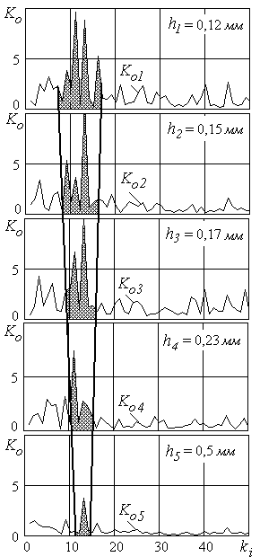
In the case of significant differences under treatment conditions the values of the anharmonicity coefficients allow us to estimate differences in the structure of the harmonic series, to select the harmonic affecting the resulting signal at most.
Fig.3. Graphs of relative coefficients
of anharmonicity for the variants of treatment with the different wears of
instrument

Conclusion
On the basis of the proposed relative anharmonicity coefficient a comparative evaluation of harmonic composition of the cutting EMF for different treatment variants is given. Regularities of EMF harmonic composition change as a function of cutting tool depreciation in the prosess of cutting are investigated.
The proposed method can be widely used for studies and mathematical description of the signals obtained with the help of real oscillograph recordings when measuring the parameters of the cutting process under various conditions of processing, as well as modeling and control of machining processes in general.

Literature:
1. Струтинській В.Б. Математичне моделювання процесів та систем механіки. Житомир: ЖІТІ, 2001. – 612с. 2. Матвиенко А.В., Феник Л.Н. К вопросу о влиянии ЭДС резания на шероховатость обработанной поверхности // Прогрессивные технологии и системы машиностроения. - Донецк: ДонНТУ, 2006. - Вып. 32. - С.74-77. 3. Смирнова М.А., Матвиенко А.В., Ивченко Т.Г. Применение методики определения гармонического состава сигналов при анализе параметров процесса резания // Надійність інструменту та оптимізація технологічних систем. Вип.21. – Краматорськ: ДДМА, 2007.- С.312-318. 4. Смирнова М.А. Определение гармонического состава токов и напряжений при измерении сил резания в механообработке // Наукові праці Донецького національного технічного університету. Серія: Машинобудування і машинознавство. Випуск 4 (124) - Донецьк, ДонНТУ, 2007.- С.49-55. 5. Смирнова М.А. Методика определения гармонического состава и симметричных составляющих токов и напряжений в переходных режимах электромеханических систем // Практика и перспективы развития партнерства в сфере высшей школы. - Донецк: ДонНТУ. Том 3. 2007. – С.320 - 329.

