**The Institutional Framework: PFTS and UKRSE**

**Khomenko Y.V.**

Professor of the Department of

International Business Activity, DonNTU

**Nesterenko K.A.,**

**Bodnar A.V.**

Students majoring in «International economics»,

DonNTU

In Ukraine today the stock market is a major source of funding for corporations. By its very nature it is a mechanism to accumulate temporarily free funds from the population and business structures, allocate them to productive purposes and to ensure, therefore, the flexible flow of the capital among the sectors of the economy. The more reliable, sustainable and effective this mechanism is, the more likely it is to attract the necessary capital.

With the globalization the stock market becomes more far-reaching. Prospective investors are more interested in new areas for capital investment outside their country. As Templeton maintains, ‘In London and New York share prices get out of line in value, but in other places they get even further out of line. You get better bargains in addition to more bargains by looking world wide’[1]. In this regard, the stock market should be seen as an ideal mechanism through which we can create conditions for releasing the capital to the financial markets of other countries.

To meet the increased interest in global equity investing a universal tool for measuring the performance of foreign stock markets is needed. This need is covered by the internationally accepted range of stock prices indexes. By stock index we understand a gauge of the revenue which can be gained by the holder of a specific set of shares. This is a numerical representation of price movements for a set of stocks relative to their baseline values at the start date in the past [2].

An important role of the stock market indices in developing the world capital market is emphasized by the majority of scholars and economists. Lyashenko and Pavlov see the value of indices in the fact that ‘they give concise information about prices in the market or in its particular segment as a simple reference figure, which helps investors and analysts assess the demand for stocks and forecast the future price movements’[3]. Fabozzi et al. consider the global stock indexes as the most ‘reliable indicators of the overall performance of international stocks and markets’ [4]. Solnic and McLeavey maintain that only the stock market indexes ‘allow one to measure the average performance of a national market’ [5]. Taking into account all these views it gets relevant to make asset allocation decisions and stock market performance measurements on the bases of the stock indexes analysis.

In view of the abovementioned this paper is to answer the questions: *how has the institutional framework of PFTS and UKRSE changed during the last ten years, what problems does it have, and what has to be done to solve these problems?* This issue is approached by analyzing the evolution of institutional framework of PFTS and UKRSE, the Ukrainian stock market’s 10-year development, by viewing and comparing with changes in the institutional framework. The database for research comprises the Law of Ukraine “On Securities and Stock Market”, the current accounts and archives of the National Bank of Ukraine, National Board of Statistics, Stock Exchange of the First Stock Trade System, the Financial Times – Stock Exchange. The following methods of the research are applied: comparative analysis and technical analysis.

Before analyzing the institutional framework of PFTS and UKRSE it is crucial to look through its evolution, and to find out what problems we had in the past and what problems we should solve now.

Ukraine has taken the path of social reform in the late XX century, when the world was experiencing globalization of all processes, including the economic ones. The experience of developed countries creates the need in adopting their experience to improve living standards and increase the capacity of the state. The formation of the securities market in Ukraine used international practice and began to create the history of a civilized market development. It begins with the adoption of the Law of Ukraine "On Securities and Stock Exchange" in 1991.

1991-1992 is a period of the occurrence of the first Ukrainian shares and security traders, as well as the Ukrainian Stock Exchange (UKRSE) (1991). Before May 1995, the UKRSE was the only officially registered stock exchange in Ukraine. But the development of the stock market infrastructure went through the opening of the UKRSE branches (in 1992 there were 22 branches, in 1994 there were 27 branches and 2 regional centers). The participants of trading were financial intermediaries. On the Ukrainian stock market they were trust companies, investment funds and companies, as well as commercial banks. At the beginning of 1995 in Ukraine there operated 228 commercial banks, 500 trust companies and 500 investment companies and funds.

In 1994, the government measures were taken to significantly increase the capacity and the structure of financial markets. The most important part of the development was the "Concept of the operation and development of the stock market of Ukraine" and the Law of Ukraine "On State Regulation of Securities Market in Ukraine", as well as the decision on the issue of government securities, the issuance of which was to become one of the efficient mechanisms to cover the deficit of the state budget. Thus, by the end of 1994, the foundations of the institutional and legislative activities of the Ukrainian stock market were made.

The rapid growth in emissions in government securities was a characteristic feature of the securities market development in Ukraine in 1995. This process was even more dynamic than the movement of securities on the stock market. In particular, 1995 was the beginning of the practice of issuing government securities to cover the state budget deficit in Ukraine.

Describing the stock market in 1997 and 1998, it should be noted that over the years there was produced the greatest volume of trading.

The next stage of the Ukrainian stock market begins with the adoption by the Ukrainian President Leonid Kuchma of the Decree "On Additional Measures on the Stock Market Development of Ukraine" dated 26.03.2001, which was approved by the "Main directions of development of the stock market of Ukraine for 2001-2005". In 2006 the law “On Securities and Stock Exchange” was modified because the market needed such modification. Also in 2006 the law “On Joint-Stock Companies” was created and it was also modified in 2009.

In the section to follow the dynamics of stock market development in Ukraine for the period from 2000 to 2010 will be considered. Stock indexes are the main tool of analysis here.

An index of the Stock Exchange of the First Stock Trade System (PFTS) is accepted as the basic index of the Ukrainian stock market. As of October 8, 2010 the PFTS index basket includes 20 companies’ shares in the main industries of the national economy (see Table 1).

**Table 1.** PFTS index basket 08.10.2010

|  |  |  |
| --- | --- | --- |
| Issuer | | Weight of the security |
| OJSC “Alchevsk Metallurgical Plant” | ALMK | 1.86 |
| OJSC “Avdeyevskiy Coke Plant” | AVDK | 1.13 |
| OJSC “Azovstal” | AZST | 5.35 |
| PJSC “Raiffeisen Bank Aval” | BAVL | 5.87 |
| OJSC “Centrenergo” | CEEN | 11.58 |
| OJSC “Dniproenergo” | DNEN | 1.82 |
| OJSC “ Donbassenergo” | DOEN | 2.52 |
| OJSC “ Yenakiyevo Steel Plant” | ENMZ | 2.07 |
| OJSC “Kryukov Wagon Building Works” | KVBZ | 2.02 |
| OJSC “ MotorSich” | MSICH | 13.56 |
| OJSC “Mariupol Heavy Machinery Plant” | MZVM | 0.57 |
| OJSCINTERPIPE “Nizhnedneprovskiy Tube Rolling Plant” | NITR | 1.02 |
| OJSC “Poltava Ore-Processing Plant” | PGOK | 2.42 |
| OJSC “Sumy Machine Building Enterprise named after Frunze” | SMASH | 2.10 |
| OJSC “ Concern Styrol” | STIR | 2.65 |
| OJSC “ Ukrneft” | UNAF | 14.53 |
| PJSC JSCB “Ukrsotsbank” | USCB | 3.36 |
| OJSC “Ukrtelecom” | UTLM | 8.90 |
| OJSC “Yasinevsky Coke Chemical Plant” | YASK | 1.04 |
| OJSC “ Zakhidenergo” | ZAEN | 15.65 |

Over the past decade, the Ukrainian stock market has developed quite rapidly. Figure 1 demonstrates the performance profiles of PFTS index within the last ten years. As it is shown, the first part of the decade did not emphasize the intensive development of the market, but the second part was notable for its revival. The PFTS index reached its highest level on the eve of the global financial crisis, exceeding 30.6 times the indicators of the beginning of 2000. However, the period of 2008-2009 witnessed a rapid fall in the index. During this period it fell to the level of 199.12 points (March 6, 2009). Its growth resumed in the second quarter of 2009 and was marked by a fairly high rate, restrained seasonal correction, subsequent activation in the summer months, and volatility dynamics in the last quarter. The highest PFTS value (661.1 p) was observed on 16 October (+232.0% since the beginning of the growth restoration, +119.3% YTD). At the end of the year the index amounted to 572.91 points (+90.1% since the beginning of 2009, +1362% since the beginning of 2000). In the first decade of 2010 the index exceeded 800 points.



**Figure 1.** The Performance Profile of PFTS Index, 2000-2009

Thus, basing on the values of PFTS index, the study period of the stock market development in Ukraine (2000-2010) can be divided into five stages: a slow progressive development (2000-2004), a moderate growth (2005-2006), an intensive growth (2007), a rapid fall (2008) and a recovery growth (2009-2010).

According to the results of January-July 2010 on the organized stock market of Ukraine the PFTS index grew by 238.30 points (from 572.91 to 811.21 points), or by 41.59% against the beginning of the year, and as of 01.08.2010 it accounted for 811.21 points. The maximum value of the PFTS index in July this year totalled 812.37 points (29.07.2010), the minimal - 746.43 points (07.01.2010). The following were sold most actively on the PFTS Stock Exchange in July: in the shares sector – securities of the OJSC Poltava Ore-Processing Plant (3574 agreements); in the sector of corporate bonds - bonds of JSB “Business Standard” A series (16 agreements); in the treasury bills sector - bonds maturing 20/10/2010 (10 agreements). The total number of agreements with securities on PFTS Stock Exchange in July amounted to 31,292 agreements.

As of 01.08.2010 the Stock Exchange PFTS listed 807 securities: shares - 291, corporate bonds – 320, ISE securities - 119, government bonds - 57 and municipal bonds - 20. Of them, 11 securities are listed in the quotation list of the first level, 179 securities are listed in the second-tier quotation list, and 617 securities – in the extralisting securities. Trading volume on the PFTS Stock Exchange in July 2010 increased by almost 5 times against the same period of 2009 and accounted for nearly 3.7 bln. UAH. In general, for the seven months of 2010 the volume of trading on the PFTS Stock Exchange amounted to nearly 31.0 billion UAH.

The performance of the PFTS index shows that the stock market of Ukraine proved to be very sensitive to changes in the country’s economic and political spheres. Even minor economic reforms and political developments could affect the index value. The index dynamics in 2009 has been professionally explained by the Chief Consultant of the Analytical Centre for the monetary policy issues at the Council of the National Bank of Ukraine S.Tkachenko. She believes that such index fluctuations were caused by a set of factors, including the crisis in the economy, lower ratings of Ukraine in all international rating agencies in the first quarter, a sharp drop in prices for oil and precious metals, the implementation of the IMF credit programs Stand-By Arrangement (stand-by ) and cooperation with other international financial organizations, volatility of the relations between CJSC Neftegaz Ukraine and OJSC Gazprom in the issues of the gas transportation system functioning.

Having described the history of development of the institutional framework of PFTS and UKRSE we can approach analyzing the current problems of the institutional framework and finding the solutions for these problems.

There are such main problems and threats of market development:

1. Low market liquidity.
2. High market volatility.
3. High dependence on the world stock market development.
4. Low level of confidence among households and ordinary shareholders.
5. Low speed of market operations due to the lack of sufficient technical equipment.
6. High influence of non-residents on the market development.
7. Lack of sufficient information for decision making.
8. Low level of citizens’ competence in the stock market theory.

One of the biggest problems of Ukrainian stock market is low market liquidity. Daily turnover of PFTS is 30-40 million UAH. But, for example, the daily turnover of MICEX (Moscow stock exchange) is 1-2 billion dollars. The problem of low market liquidity creates another one: high market volatility. If world stock indexes fall by 10%, PFTS may fall by 40% (See Figure 2).

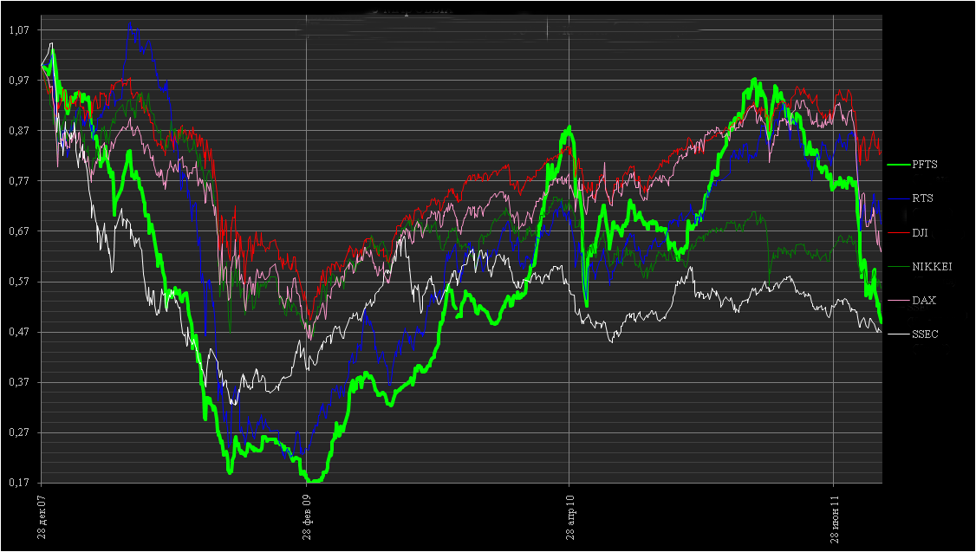

**Figure 2**. Worldstock indexes movement (December 2007-June 2011)

In Ukraine there is a very low level of confidence among households and ordinary shareholders. Only 7% of Ukrainians know what stock market is. Low speed of market operations due to the lack of sufficient technical equipment is also a big problem. Only in 2008 several brokers started providing online-trading services for its customers. Also, low market liquidity creates another problem: the main role in it is played by non-residents. They can raise and lower the market by rapid input and output of capital. There is a lack of sufficient information for decision making. For example: in 2008 2 billion UAH were invested in stock market, but 160 billion UAH were invested in bank deposits. It shows that there is a low level of citizens’ competence in stock market theory. In the USA and Western Europe 20% of citizens invest money in stock market, but in Ukraine it is less than 1%.

To solve these problems it is necessary to find further directions of market development. First of all the institutional framework should be improved. To find out the directions of institutional framework improving let us make the monitoring of its development.

First let us see the chart of PFTS index from 1997 to 2011 (See Figure 3).

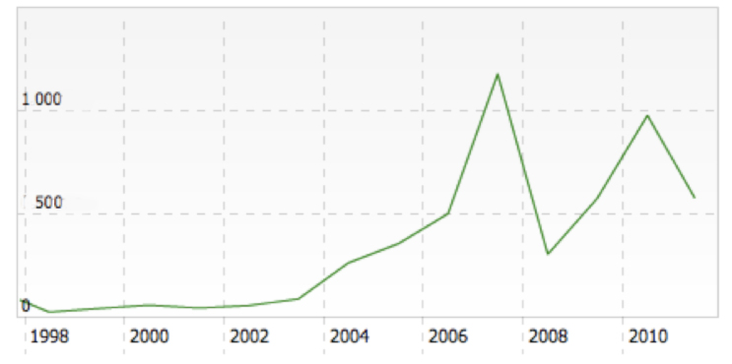

**Figure 3.** PFTS index (1997-2011)

As we can see in the beginning of institutional framework creating for UKRSE and PFTS, the Ukrainian stock market had period of slow progressive development. The first laws “On Securities and Stock Exchange”, “On the State Regulation of the Stock Market”, “On the National Depository System and Specificities of Securities’ Electronic Circulation in Ukraine”, creating the state commission for securities and stock market, all these things were made for the start of the Ukrainian stock market. It was the beginning. In those times the laws worked well enough, as we can see a slow growth.

In 2002 the Verhovna Rada made the project "On the Equity Securities and Stock Exchange", as agreed with the EU directives. This was the first step of the institutional framework modernization. According to experts, 2003 was one of the most successful years for the Ukrainian stock market. It grew and became more transparent, its participant’s corporate culture improved. The most important event for the stock market was the adoption of a new Commercial Code for PFTS. This led to improvement of the securities’ liquidity. In 2003, there were increased demands on the level of disclosure by issuers of bonds during the passage of the PFTS listing, requirements to level of liquidity needed to stay in the List of Issuer PFTS, approved the provision of the Institute for market makers. This provoked the beginning of moderate growth. And in 2006 the main law of the institutional framework of PFTS and UKRSE was modernized. This event and economic growth provoked the intensive growth (See Figure 4).

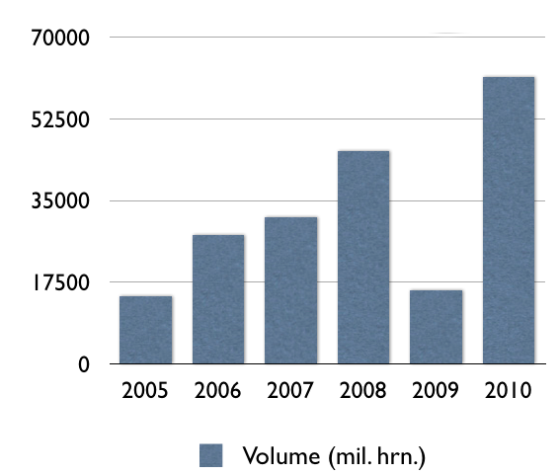

**Figure 4.** Stock Market Volume

Next years were also good for the stock market because of economic growth. But in the end of 2008 the rapid fall started. And in 2009 and 2010 there was a recovery growth. In these times, especially in 2008 and 2009 the institutional framework needed more modernization and adaptation according to necessity. But it was not executed. Only the law "On Joint Stock Companies" was adopted in 2009 and helped the market.

So we can make a conclusion: the government must always modernize the institutional framework according to the necessity, and try to learn from the experience of foreign countries.

The next step in improving of current situation on the stock market is households attraction to the stock market. This will increase the stock market activity. And we will have better developed market infrastructure, because brokers will have more clients and profits. There is a big necessity in providing of high qualified technical services for speeding market operations. So we need to make it by investing money in market infrastructure. Another big step will be accelerating the activity of institutional investors. This is very important because it can raise the liquidity of the market. It would be very good to create the institutional investors association.

**References**

1) Bodie, Z./Kane, A./Markus A.J. (2005), Investments, 6th ed., McGraw-Hill/ Irwin: New York.

2) Colander, D.C. (1995), Economics, 2nd ed., Irwin: Chicago.

3) Fabozzi, F. J./Modigliani F./Ferri, M.G. (1994), Foundations of Financial Markets and Institutions, Prentice-Hall Inc.: Englewood Cliffs.

4) Sears, S.R./Trennepohl, G.L. (1993), Investment Management, The Dryden Press: Orlando.

5) Shim, J.K./Siegel, J.G. (1988), Handbook of Financial Analysis, Forecasting, and Modeling, Prentice-Hall Inc.: Paramus.

6) Solnik B./McLeavey D. (2003), International Investments, 5th ed., Pearson: New York.

7) Vaitilingam, R. (1996), Guide to Using the Financial Pages, 3rd ed., Pitman Publishing: London.

8) Динаміка Індексу ПФТС за 2000-2009 роки, available at:

<http://www.pfts.com/uk/trade-results/>, 02.10.2010.

9) ІндекснийкошикІндексуПФТС, 08.10.2010. Рішення індексного комітету, available at:<http://pfts.com/uk/indexes/>, 13.10.2010.

10) Ляшенко, В.И./Павлов, К.В. (2007), Фондовые индексы зарубежных стран, Магистр: Москва.

11) Ткаченко, С. (2010) Оцінка стану і перспективи розвитку фондового ринку України, in Вісник НБУ,No. 9, С. 44-50. Use Ukrainian standard to describe Ukrainian sources